Installation, Operating and Maintenance Manual

CVA Eductors

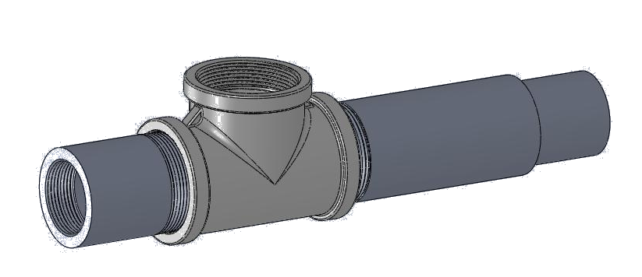

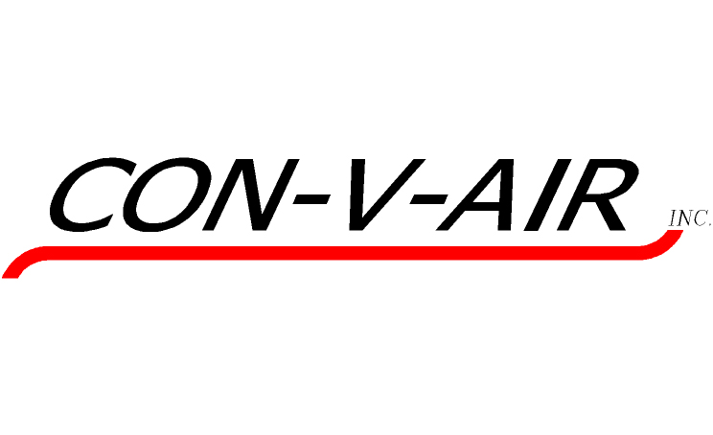

CON-V-AIR inc.
3500, 1st Street
St-Hubert (Quebec)
J3Y 8Y5

Congratulations on your recent purchase of Con-V-Air equipment. We would like to thank you for placing this order with Con-V-Air. The equipment you have purchased is the most reliable, state-of-the-art equipment on the market, and will deliver many years of service.

This manual has been prepared as a guide to those involved in the installation, use and maintenance of CVA Eductors. All instructions should be read carefully and understood before beginning installation. Failure to follow this manual could result in leakage of fluid, injury to personnel or property damage.

WARNING: Safety glasses should be worn when Eductors are being installed or used in an area.

Introduction:

Eductors work by accelerating the motive fluid used through them. It is important that all downstream sections of the eductors be treated as a high velocity area. The conveyed material is also accelerated in the venturi area giving it enough energy to be conveyed over relatively long distances.

The Eductor is self regulating in the sense that it will draw the required amount of material from the hopper so it can be used in “Flood Feed” applications in most cases. Other applications may require a metered inlet flow. Check with Con-V-Air before installing an Eductor for proper Engineering.

Inspection:

Con-V-Air recommends that you inspect all Eductors upon receipt. Ensure that the nameplate information matches with your Application. Do not use an Eductor that was not specifically designed for that application.

Eductors should bear a nameplate and be in perfect condition.

Installation:

Eductor installation should only be done by trained and qualified personnel who have read this manual.

Eductor connections come in various sizes so consult Eductor drawing for complete information. Eductor orientation will also be read from the drawing. Eductor nozzle tip should be located at the center of the material inlet port unless otherwise noted on the drawing. Moving it either way will modify Eductor performance and Con-V-Air should be contacted before doing so.

All piping used in the installation should be clean and free of debris that could clog the Eductor. Piping should be in good shape and adequate to withstand Eductor maximum rated pressure.

Install Eductor and Blower in a way that proper flow and motive fluid pressure will be available at the Eductor. Ensure there are no restrictions in the material chute or hopper above the Eductor so that bridges do not form. Ensure Eductor outlet piping has no sharp bends and that its equivalent length matches the Eductor Specifications noted on the drawing.

When all connections are secured, a dry run can be performed to ensure all connections are tight and free of leaks. When the system is complete, a qualifying run should be done to prove Eductor performance. Contact Con-V-Air if performance does not meet the Specifications.

Operation:

- Ensure all guards and safety precautions are in place.
- Start blower or open valve supplying motive fluid.
- Confirm that the line is not clogged.
- If material inlet is metered, open inlet valve or start feeder.

Shut down is done in reverse order.

It is normal that the flow be somewhat irregular as the Eductor is self regulating. Consult Con-V-Air if in doubt about proper operation.

CAUTION: Eductor can be hot or cold. It can also be hot at one end and cold at the other.

Maintenance:

Maintenance should only be performed by trained and qualified personnel.

WARNING: Safety glasses should be worn when Eductor are being dismantled, worked on, tested, installed or used in an area.

WARNING: All pressure or vaccum must be drained from the Eductor before any work is performed on the system. All fluids or material must be removed from the Eductor before beginning maintained. Eductor must also be allowed time to reach ambient temperature.

CAUTION: Eductor can be hot or cold. It can also be hot at one end and cold at the other.

Things to check:

- Eductor nozzle for erosion or build up of debris.
- O-ring seals for wear or damage.
- Set screw condition
- All connections for debris, corrosion and tightness.
- General wear in all areas of the Eductor.
- Build ups of material anywhere.

Preventive maintenance schedules are dependent on actual conditions in the user’s facility. The user should create a maintenance schedule based on their experience with the actual fluid / material being conveyed with the Eductor.

Troubleshooting:

- Flow rate seems too low or zero flow.
  - Check for restrictions in material inlet
  - Check for clogs inside the Eductor.
  - Verify motive fluid pressure and flow rate. Important to match the Eductor Specifications. Using more or less motive fluid has significant impact on Eductor performance.
  - Inspect Eductor for wear or erosion.

- Flow rate seems too high
  - Verify motive fluid pressure and flow rate. Important to match the Eductor Specifications. Using more or less motive fluid has significant impact on Eductor performance.
  - Check material inlet flow if inlet is metered.

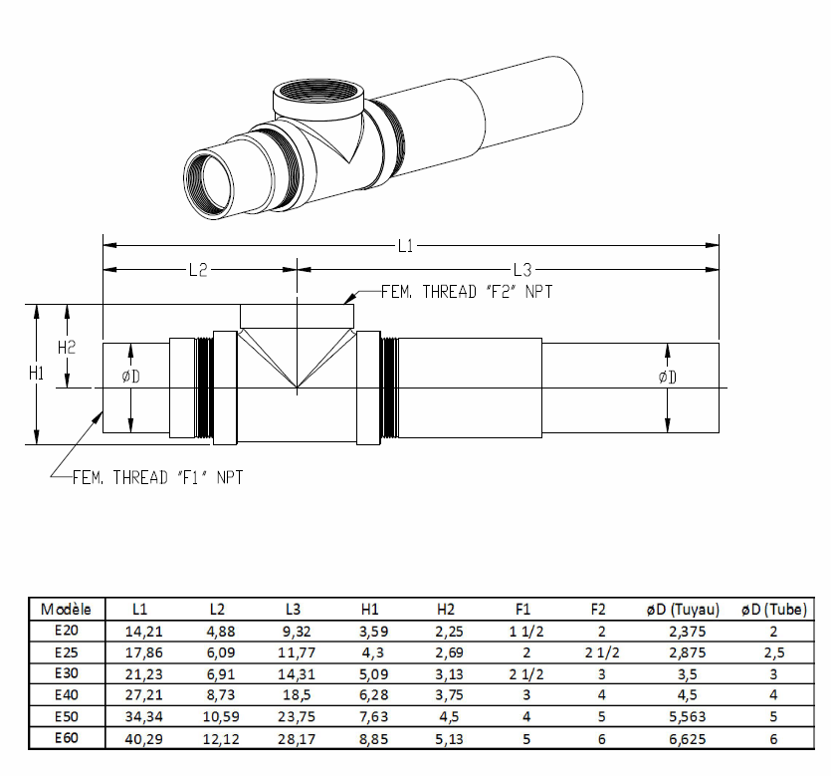
Dimensions:

Sanitary Dimensions:

