Operation and installation manual

Bulk Bag Unloading system

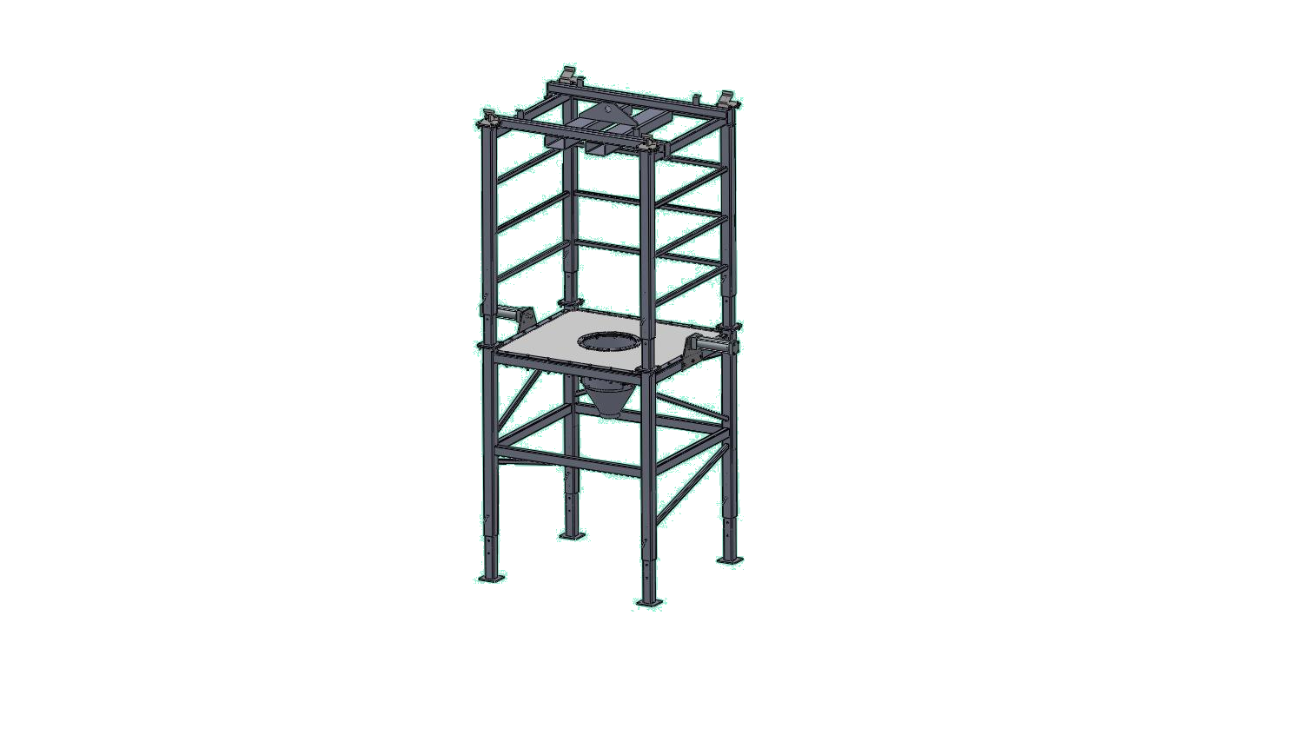

MODÈLE/MODEL BBUFL

ITEM | DESCRIPTION | DÉSIGNATION
1 | LOWER STRUCTURE | STRUCTURE INFÉRIEURE
2 | UPPER STRUCTURE | STRUCTURE SUPÉRIEURE
3 | SLIDING LEGS | PIED COULISSANT
4 | GASKET | JOINT D’ÉTANCHÉITÉ
5 | GASKET FLANGE (LONG) | BRIDE DU JOINT D’ÉTANCHÉITÉ(LONGUE)
6 | GASKET FLANGE (SHORT) | BRIDE DU JOINT D’ÉTANCHÉITÉ(COURTE)
7 | GASKET FLANGE (ROND) | BRIDE DU JOINT D’ÉTANCHÉITÉ(RONDE)
8 | CYLINDER BRACKET | SUPPORT CYLINDRE MASSEUR
9 | HOPPER WITH ACCESS DOOR | TRÉMIE AVEC PORTE D’ACCÈS
10 | BULK BAGS STRUCTURE | STRUCTURE SUPPORT SUPER SAC
11 | GUIDE | GUIDE POUR STRUCTURE SUPPORT SUPER SAC
12 | OLI VIBRATOR | VIBRATEUR OLI
13 | HITCH PIN | TIGE CYLINDRIQUE

MODÈLE / MODEL BBUH

ITEM | DESCRIPTION | DÉSIGNATION
1 | LOWER STRUCTURE | STRUCTURE INFÉRIEURE
2 | UPPER STRUCTURE | STRUCTURE SUPÉRIEURE
3 | SLIDING LEGS | PIED COULISSANT
4 | GASKET | JOINT D’ÉTANCHÉITÉ
5 | GASKET FLANGE (LONG) | BRIDE DU JOINT D’ÉTANCHÉITÉ(LONGUE)
6 | GASKET FLANGE (SHORT) | BRIDE DU JOINT D’ÉTANCHÉITÉ(COURTE)
7 | GASKET FLANGE (ROND) | BRIDE DU JOINT D’ÉTANCHÉITÉ(RONDE)
8 | CYLINDER BRACKET | SUPPORT CYLINDRE MASSEUR
9 | HOPPER WITH ACCESS DOOR | TRÉMIE AVEC PORTE D’ACCÈS
10 | RAIL STRUCTURE | STRUCTURE POUR MONORAIL
11 | UPPER BEAM | POUTRE SUPÉRIEURE MONORAIL
12 | LOWER BEAM | POUTRE INFÉRIEURE MONORAIL
13 | SAFETY STOPPER | ARRÊT DE SÉCURITÉ
14 | LIFTING CROSS | CROIX DE LEVAGE
15 | OLI VIBRATOR | VIBRATEUR OLI
16 | HITCH PIN | TIGE CYLINDRIQUE

TECHNICAL DATA
BAGS size :
Maximal vertical dimension : 72"
Maximal width : 46,5"
Discharge spout diametre : 18"
Discharge spout lenght untill 24"
Loading capacity of 2 metric ton;

- Heavy duty seal supporting bag for a perfect sealing
- Access door with quick clips. (No tools required)
- Flexible conduct connects to universal adapter. This can then be connected to a rotary valve, a screw feeder or any other equipment required by the process.
- Lifting cross for easy grab with a fork lift.
- Built of stainless steel 304 or carbon steel.
- Easy assembly requires only bolting.
- Adjustable legs for the lower structure and upper structure, 7 positions distanced by 4 inches each for a total of 56 inches of adjustment. Holding through cylindrical rods.
- Adjustment to allow the emptying of bags of different sizes

OPTIONS :
- Diaphragm valve (IRIS Valve) allows the opening of the bag while having the access door closed
- Motorized hoist and trolley for operation without forklift;
- Dust collecteur connection;
- Level detector plug;
- installation on load cells.

Advantages :

- Fast assembly and disassembly of parts and accessories

- 2 different models, used upon available resources. Fork lifts access model or hoist and trolley loading.

- Operators are protected against bags falls with rigid chassis support.

- Door provides easy access to the interior of the hopper.

- Massing cylinders improve the emptying of bulk bags.

Contraindications :
- Bulk bag unloading system is not designed to be in contact with hazardous materials. Where appropriate, it is mandatory to inform the manufacturer.

Explosive, flammable, toxic and / or harmful materials are considered dangerous materials

- Working temperature : -20°C / 55°C

Accessories :
- The pneumatic actuators provide a massage to the lower part of the bulk bag in situations where slightly fluid materials do not flow easily. The progressive movement of the massing cylinders make a "V" at the bottom of the bag, allowing the removal of dead points and thus a more efficient flow of material.

Construction :
- Carbon steel or stainless steel.

Foundations

TOTAL DYNAMIC VERTICAL LOAD: 4100 daN
TOTAL HORIZONTAL LOAD: Mf max 500 daN * m

Anchorage system not provided. Use anchor bolts adapted Ø ½-13UNC. We recommend using grade 8 bolts, since they bear the greatest loads of the system.

