SPECIFICATIONS BULK BAG UNLOADING STATION

FORK LIFT VERSION

MODEL L.BBU-FL

- Heavy-duty square tubing construction fully adjustable to match bag height and underneath equipment height. Structure is welded and bolted for stability, durability and reduced shipping volume;
- Carbon steel construction;
- Extra heavy duty rubber 48" x 48" seal 2-ply 220-PLW above hopper;
- Directly bolted hopper on heavy duty seal to minimize fugitive dust
- Hoist rail, W8 x 18, carbon steel construction
- Bag lifter frame to match hoist (not included);
- Massager system
- Pneumatically actuated cylinder
- Fully automatic massaging cycles with adjustable timer and control panel;

- Iris valve, 12" I.D., manually-operated (OPTION)
- Access hopper
  - Hinged door with toggle clamps
  - Vent stub, for connection to dust collection
  - Inlet and outlet flanges

- Industrial enamel LEAP paint white and Orange

HOIST VERSION

MODEL L.BBU-H

- Heavy-duty square tubing construction fully adjustable to match bag height and underneath equipment height. Structure is welded and bolted for stability, durability and reduce shipping volume;
- Carbon steel construction
- Extra heavy duty rubber 48" x 48" seal 2-ply 220-PLW above hopper;
- Directly bolted hopper on heavy duty seal to minimize fugitive dust
- Forklift load capability
- Bag lifter frame to match fork lift or hoist (not included);
- Massager system
- Pneumatically actuated cylinder
- Fully automatic massaging cycles with adjustable timer and control panel;

- Iris valve, 12" I.D., manually-operated (OPTION)
- Access hopper
  - Hinged door with toggle clamps
  - Vent stub, for connection to dust collection
  - Inlet and outlet flanges

- Industrial enamel LEAP paint white and Orange

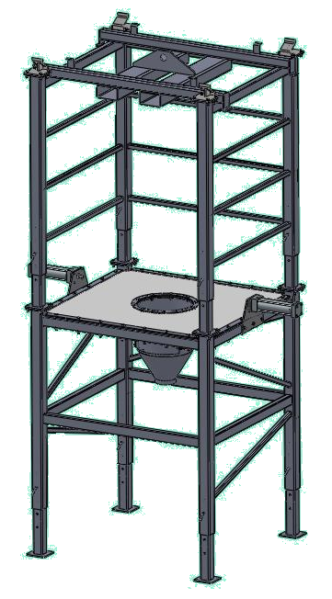

Application data sheet – Bulk bag unloader

Please fill this form with all necessary information for our engineers to set a price for
the realization of your project.

PLEASE FAX TO 450-462-0756 THANK YOU

Client name:
Contact agent :
Phone number:
E-Mail:

Material(s) |  |  |  | Bulk density
 | 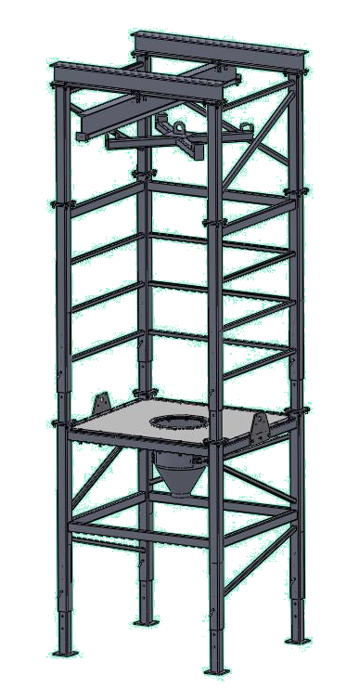
Name: |  |  |  | Moisture content (%)
 |  |  |  | Temperature
 |  |  |  | Hygroscopic
 |  |  |  | Abrasive
 |  |  |  | Corrosive
 |  |  |  | Toxic
 |  |  |  | Explosive (class/division)
 |  |  |  | Free flowing
 |  |  |  | Aeration
 |  |  |  | Dimension (µm)

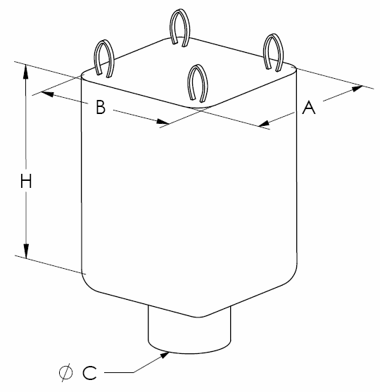  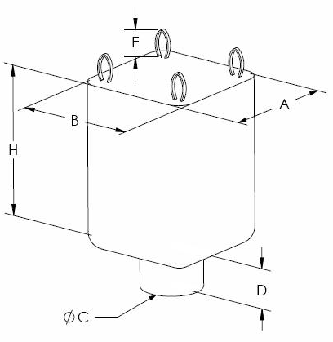  Bag dimensions |  |  |  | Width A
 |  |  |  | Length B
 |  |  |  | Height H
 |  |  |  | Discharge spout outside Ø C
Discharge spout
height (D)
 |  |  |  | Hook height (E)

Contact parts material |  |  |  | Carbon steel
 |  |  |  | Stainless steel
 |  |  |  | Food grade
 |  |  |  | Paintings requirements

Electrical power source |  |  |  | Phase
 |  |  |  | Cycle
 |  |  |  | Volts

Installation room dimensions |  |  |  | Width
 |  |  |  | Length
 |  |  |  | Ceiling height

Options |  |  |  | BBUFL
 |  |  |  | Fork lift loading
 |  |  |  | BBUH
 |  |  |  | Hoist & trolley loading

Flowing aid options |  | 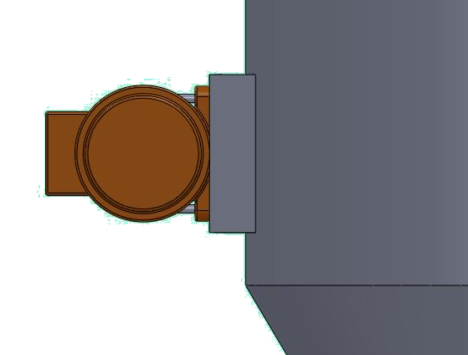 |  | Hopper vibration
 |  |  |  | 110v/1/60hz
 |  |  |  | Massaging device
 | 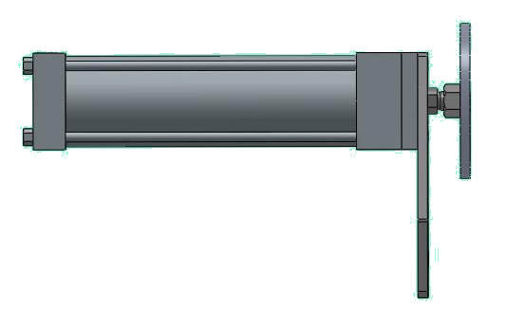 |  |  | 110v/1/60hz
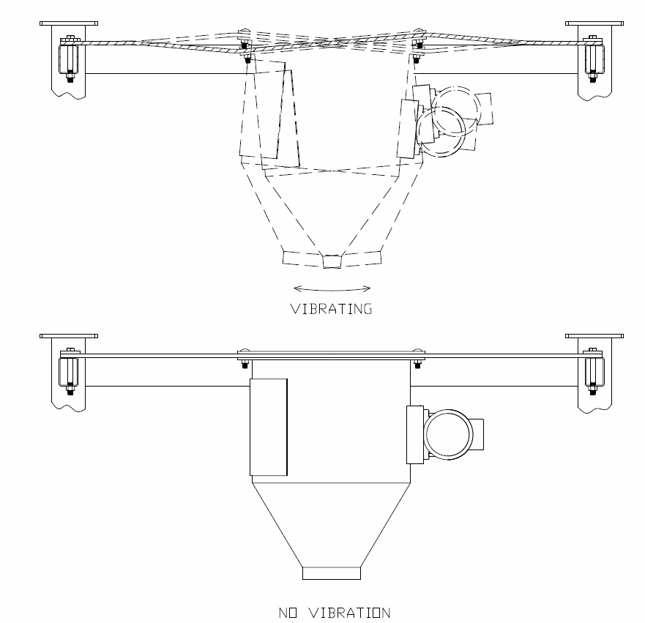 |  |  |  | Control panel
 |  |  |  | For flowing aids
 |  |  |  | Dust collector port

