SPECIFICATIONS CONVEYING EDUCTOR

MODEL L.E.1

- Conveying eductor machined from bar rated for a capacity of ______#/hour of ________(name material to be conveyed) over an horizontal conveying distance of _____ft and a vertical conveying distance of _____feet with ____ 90 degrees long radius elbows.

- The material inlet must be in Stainless Steel;

- The nozzle must be carbon steel painted with threads to match material inlet TEE.

- Nozzle must be machined to operate at a pressure of _____PSI at a flow rate of ______SCFM. Mach number across the nozzle should be between 0,27 and 0,40.

- The eductor must be designed to operate at an altitude of _____Feet above sea level;

- The venturi part must be made of painted carbon steel.

- It shall be threaded and machined to fit a conveying line of _____inches inside diameter and _____inches outside diameter.

- The venturi section must be replaceable without changing the material inlet TEE.

- Paint Orange LEAP industrial enamel.

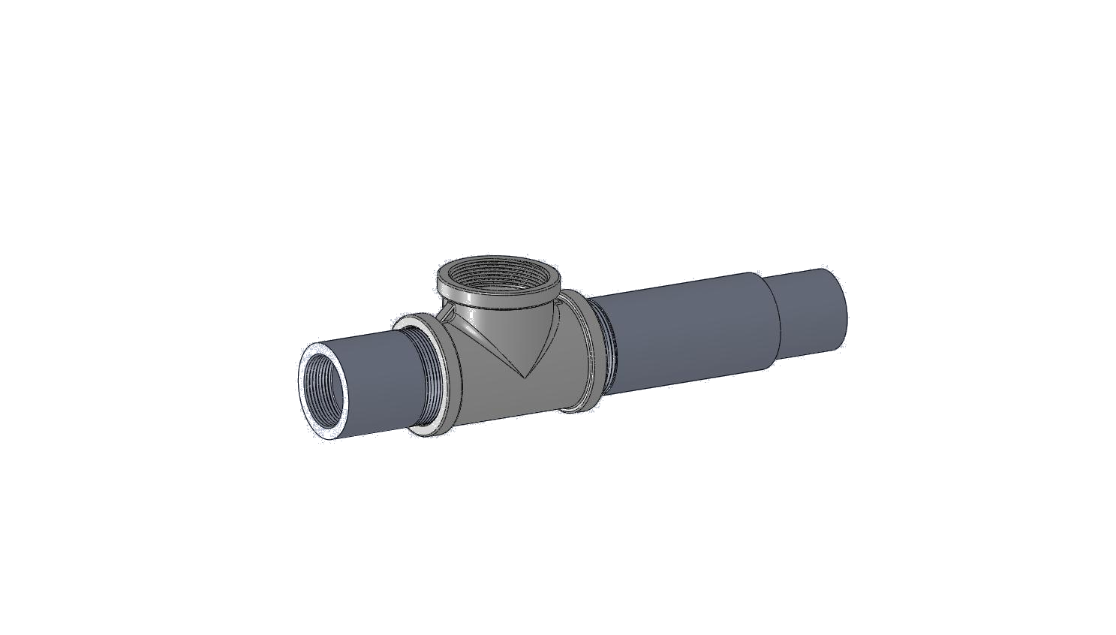

Application data sheet – Pneumatic conveying eductor

Please fill this form with all necessary information for our engineers to set a price for the realization of your project.

PLEASE FAX TO 450-462-0756 THANK YOU

Client name:
Contact agent :
Phone number:
E-Mail:

Material(s) |  |  |  | Bulk density
Name: |  |  |  | Moisture content (%)
 |  |  |  | Temperature
 |  |  |  | Hygroscopic
 |  |  |  | Abrasive
 |  |  |  | Corrosive
 |  |  |  | Toxic
 |  |  |  | Explosive
 |  |  |  | Free flowing
 |  |  |  | Aeration
 |  |  |  | Dimension (µm)

Conveying data |  |  |  | Conveying rate (lbs/hr.)
 |  |  |  | Horizontal distance (ft.)
 |  |  |  | Vertical distance (ft.)
 |  |  |  | Number of long radius elbow(s)
 |  |  |  | Altitude above sea level

Fabrication material |  |  |  | Carbon steel
 |  |  |  | Stainless Steel 304
 |  |  |  | Stainless Steel 316
 |  |  |  | Carbon steel ceramic lining

Electrical power source |  |  |  | Phase
 |  |  |  | Cycle
 |  |  |  | Volts

Miscellaneous |  |  |  | Available air pressure
 |  |  |  | Available line (insideØ)
Paint finish
specifications
 |  |  |  | Weld specifications
 |  |  |  | Motive fluid type
 |  |  |  | Air
 |  |  |  | N2
 |  |  |  | Others

